
Launching into Computing
A Comparative Analysis of Bubble Sort and Quick Sort: Theory, Complexity, and Practical Performance

August 22, 2025
University of Esses Online
Tutor: Dr. Samuel Danso

Sorting text, numbers, and other items is a core computational process in the digital world, and it provides foundation framework for applications ranging from database queries to e-commerce search results. It also underpinning AI systems, machine learning, database management, and numerous digital applications, as it strengthens data retrieval efficiency, enhance system performance, and optimises computational resources (Algorithm Examples, n.d.)
Sorting algorithms are commonly classified into four categories. Comparison-based directly compare elements examples include Bubble Sort, Quick Sort, and Comb Sort. Non-comparison-based which exploit inherent properties of the elements instead of direct comparison as seen in Counting Sort. Hybrid which combines strategies for better real-world performance; TimeSort is a well-known example used in Java and Python. Finally, Specialised algorithm which has been designed for constrains or data patterns such as FlashSort (BytePlus, 2025).
In this report I will look at how Bubble Sort, and Quick Sort work in practice. The discussion summarises how each one organizes the data, compare the differences in their methods and review their efficiency changes with the size of dataset and the context in which they are used.
Bubble Sort is a simple comparison-based algorithm. As shown in Figure 1, Bubble Sort repeatedly going through a list and swapping any two adjacent numbers that are in the wrong order. this process will be terminated when all the list’s elements have been sorted. The name come after the fact that smaller values slowly bubble their path to the top of the list with each stage (Cormen et al., 2009).
GreekforGeeks (2024) describes the Quick Sort as an algorithm based on the divide and conquer approach. It picks a element/ number as a “pivot” and partitions the list into two groups: one containing smaller elements than pivot and the other containing the elements/numbers greater than pivot. This process will apply recursively to each sub-list until all the numbers/elemnts are in order. Finally all sub-lists will be combined to create the final sorted list. Figure 2 demonstrates an example of Quick Sort functionality.In order to compare these two algorithms a scale to measure their componentsis needed.

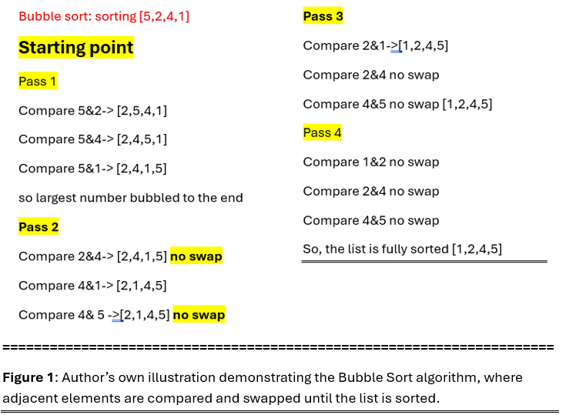
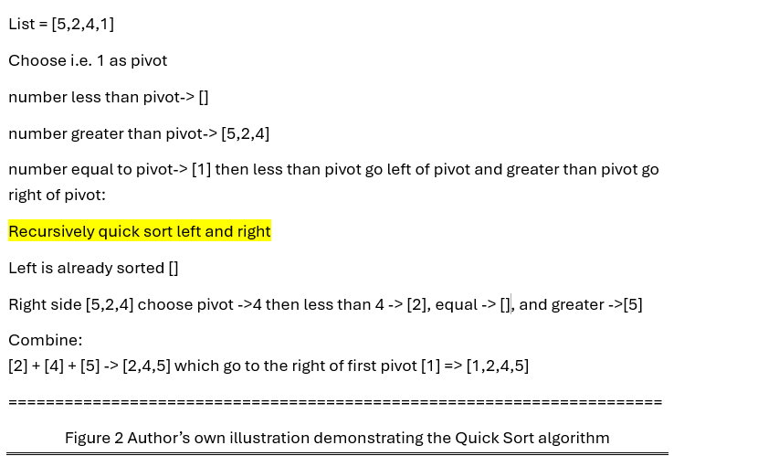
Big-O notation is a way to show how an algorithm's speed or memory utilisation changes when you feed it more data. This lets you compare how well an algorithm works in a method that doesn't depend on the implementation (GeeksforGeeks, 2025). Table 1 and Table 2 illustrate that Bubble Sort achieves a best-case time complexity of O(n) when the input is already sorted, but it offers O(n²) performance on average and worst-case that make it unsuitable for large datasets as the operation time grows much more faster (exponentially) than Quick sort as the size of dataset is increased (GeeksforGeeks, 2024).

Complexity | Description | Example
O (1) | Constant time — doesn’t grow with input | Accessing an array element
O(n) | Linear time — grows proportionally | Looping through a list
O (log n) | Logarithmic time — grows slowly | Binary search
O (n log n) | Log-linear time — grows faster than linear but much slower than quadratic | Merge sort, average-case quicksort
O(n²) | Quadratic time — grows rapidly | Nested loops (e.g., Bubble Sort)

Table 1: Common algorithmic time complexities with examples (adapted from freeCodeCamp, 2022).
Algorithm | Best Case | Average Case | Worst Case | Notes
Bubble Sort | O(n) | O(n²) | O(n²) | Simple to implement but inefficient for large datasets
Quick Sort | O (n log n) | O (n log n) | O(n²) | Fast in practice, worst-case occurs with poor pivot selection
Merge Sort | O (n log n) | O (n log n) | O (n log n) | Consistent performance; requires additional memory for merging steps

Table 2: Comparative time complexities and characteristics of selected sorting algorithms. Adapted from Cormen et al. (2022) and GeeksforGeeks (2024).

A practical experiment backed up this theoretical analysis. Bubble sort was first written as a stand-alone program, and then it was written so that it could run at the same time as the quick sort algorithm. Both versions were made in Python using the Jupyter Notebook environment. The Anaconda Assistant (Anaconda Inc., 2024) was helpful in fixing early syntax and runtime errors during development. After the algorithms were finished and free of errors, their run times were recorded for different input sizes. Figure 3, and 4 (next page) show the data that came out of this process. It shows very clearly how each algorithm scales differently.
In conclusion, Quick Sort offers a clear advantage over Bubble Sort for most real-world senarios where performance and scalability are priorities, while Bubble Sort remain best suited for very small dataset or educational purpose.

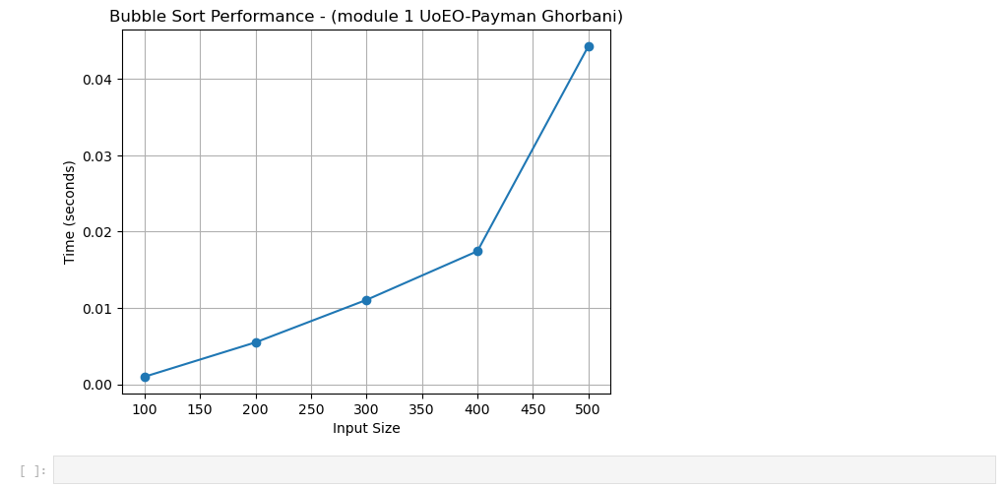
Figure 3

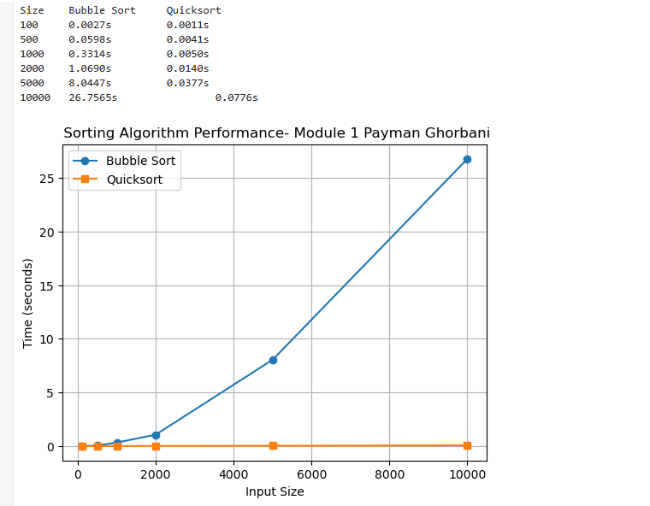
Figure 4

Reference list
Algorithm Examples (n.d.) Why are computer sorting algorithms vital in real-world? Available at: https://blog.algorithmexamples.com/sorting-algorithm/why-are-computer-sorting-algorithms-vital-in-real-world/ (Accessed: 21 August 2025).
Anaconda Inc. (2024). Anaconda Assistant [AI coding assistant]. Available at: https://www.anaconda.com/products/individual (Accessed: 24 May 2024).
BytePlus (2025) Comparison vs Non-Comparison Sort: Ultimate Guide to Algorithmic Efficiency. Available at: https://www.byteplus.com/en/topic/408187?title=comparison-vs-non-comparison-sort-ultimate-guide-to-algorithmic-efficiency (Accessed: 22 August 2025).
Cormen, T. H., Leiserson, C. E., Rivest, R. L. and Stein, C. (2009) Introduction to Algorithms. 3rd edn. Cambridge, MA: The MIT Press.
freeCodeCamp (2022) Big O Cheat Sheet – Time Complexity Chart. Available at: https://www.freecodecamp.org/news/big-o-cheat-sheet-time-complexity-chart/ (Accessed: 21 August 2025).
GeeksforGeeks (2024) Time and Space Complexity Analysis of Sorting Algorithms. Available at: https://www.geeksforgeeks.org/time-complexity-of-sorting-algorithms/ (Accessed: 21 August 2025).
GeeksforGeeks (2025) Big O Notation Tutorial – A Guide to Big O Analysis. Available at: https://www.geeksforgeeks.org/dsa/analysis-algorithms-big-o-analysis/ (Accessed: 21 August 2025).
Sedgewick, R. and Wayne, K. (2011) Algorithms. 4th edn. Boston: Addison-Wesley.

